Newberry County Emergency Management
Newberry County Emergency Operations Center (NCEOC)

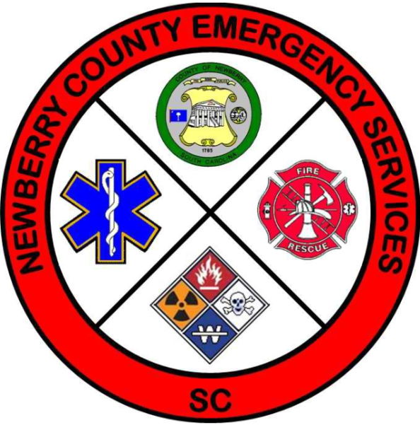

Operating Conditions (OPCON) Levels
OPCON 1 - FULL ALERT:
A DISASTER OR EMERGENCY IS IMMINENT OR OCCURING. THE COUNTY EMERGENCY OPERATIONS CENTER IS FULLY ACTIVATED. ALL COUNTY EMERGENCY RESPONSE TEAM PERSONNEL ARE ACTIVATED OR READY TO DEPLOY.
OPCON 2 - ENHANCED AWARENESS:
A DISASTER OR EMERGENCY IS LIKELY TO AFFECT THE COUNTY. EMERGENCY OPERATIONS PLANS ARE IMPLEMENTED. THE COUNTY EMERGENCY OPERATIONS CENTER IS PARTIALLY ACTIVATED IF NECESSARY.
OPCON 3 - NORMAL DAILY OPERATIONS:
AGENCIES COORDINATE, PLAN, TRAIN AND EXERCISE AS WARRANTED. INCIDENTS ARE MONITORED BY THE COUNTY WARNING POINT AND COUNTY EMERGENCY MANAGER.

